|  |  |  |  |  |
| --- | --- | --- | --- | --- |
| **Working Title of the Project:** | | **Drowsiness Detection system** | | |
| **Project Site / Location** | | SRM KTR | | |
| **Name and address of the company / organisation**  **(Applicable for projects with industry or industry support)** | | SRM University, Kattankulathur, Chengalpattu District-603203 | | |
| **Supervision Team** | | | | |
|  | **Supervisor** | | **Co-Supervisor** | **External Supervisor**  **(If applicable)** |
| **Name** | Mrs. J. Jayapradha | |  |  |
| **Designation** | ASSISTANT PROFESSOR | |  |  |
| **Department** | Department of Computating Technologies | |  |  |
| **Campus** | Kattankulathur | |  |  |
| **Telephone** |  | |  |  |
| **E-mail** |  | |  |  |

|  |  |  |  |  |
| --- | --- | --- | --- | --- |
| **Name of student** | **Register Number** | **Department** | **Mobile Number** | **Email ID**  **Project Batch ID**  B482 |
| Bathala vishal | RA1911003010495 | CSE | 9121338238 | bv9209@srmist.edu.in |
| Adit Mahajan | RA1911003010497 | CSE | 8925614488 | am6504@srmist.edu.in |

|  |  |  |  |
| --- | --- | --- | --- |
| **Degree/ program** | B.Tech | **Specialisation** | CSE |
| **Academic Year** | 2022 | **Semester** | 7 |
| **Course Code** | **18CSP107L** | **Course Title** | Minor Project |
| Mission Statement | | | |
|  | | | |
| **Problem (or) Product Description:** A drowsiness detection system for vehicles using deep learning | | | |
| **Assumptions and Constraints:** Assuming user should know how to operate vehicles and system inside it. | | | |

**Division of work and contributors**

|  |  |  |  |  |
| --- | --- | --- | --- | --- |
| **Time period** | | **Activities or components of the project** | **Name/Register Number of the Individual Contributor** | **Names/Register Number of the Joint Contributors** |
| **From Date** | **To Date** |
| 22/08 | 23/08 | The datasets which suited the project were searched and saved |  | RA1911003010495/RA1911003010497 |
| 25/08 | 28/08 | The dataset was then divided into specific folders such as open and closed eyes |  | RA1911003010495/RA1911003010497 |
| 7/09 | 11/09 | Learnt how to use the basics of deep learning |  | RA1911003010495/RA1911003010497 |
| 13/09 | 16/09 | Started implementing on our project |  | RA1911003010495/RA1911003010497 |
| 25/09 | 28/09 | Started working on the models which was required for the project |  | RA1911003010495/RA1911003010497 |
| 10/10 | 12/10 | Completed working on DL model |  | RA1911003010495/RA1911003010497 |
| 20/10 | 23/10 | Started working on real time implementation using OpenCv |  | RA1911003010495/RA1911003010497 |
| 27/10 | 30/10 | Worked on final issues and make code optimal to run |  | RA1911003010495/RA1911003010497 |
| 04/11 | 5/11 | Done the final paper and report for the project |  | RA1911003010495/RA1911003010497 |

**Summary record of major progress meetings with supervisors**

|  |  |  |  |  |
| --- | --- | --- | --- | --- |
| **Summary record of major progress meetings with supervisors** | |  | **Working title of dissertation/research project:** | |
| **Meeting date & supervisors present** | **Progress since last meeting** | **Agreed programme of work and target dates** | **Other issues, e.g. facilities, supervision, training needs, etc.** | **Date of next meeting** |
| 4/08/22 | Discussed the possible title and the steps to complete the project | Decided the project title and steps to complete it on 11/08/22 | none | 11/08/22 |
| 11/08/22 | Project Title was decided and discussed about research and base paper | base paper to be decided on 17/08/22 | none | 17/0822 |

**Summary record of major progress meetings with supervisors**

|  |  |  |  |  |
| --- | --- | --- | --- | --- |
| **Summary record of major progress meetings with supervisors** | |  | **Working title of dissertation/research project:** | |
| **Meeting date & supervisors present** | **Progress since last meeting** | **Agreed programme of work and target dates** | **Other issues, e.g. facilities, supervision, training needs, etc.** | **Date of next meeting** |
| 9/09/22 | Discussed about the challenges faced during project and talked about the architecture diagram | Architecture diagram to be decided and challenges to be solved on 23/09/22 | None | 23/09/22 |
| 23/09/22 | Discussed about the code and the data preparation | Data preparation to be done on 3/10/22 | None | 3/10/22 |
| 3/10/22 | Discussed about accuracy of our model | Real time implementation to be done by 20/10/22 | None | 20/10/22 |
| 20/10/22 | Discussed about the final issues and resolved them | demo to be made on 05/11/22 | None | 05/10/22 |
| 5/11/22 | Project completed and project report was completed | None | none | none |

**Worksheet / Data collection / Observation etc**

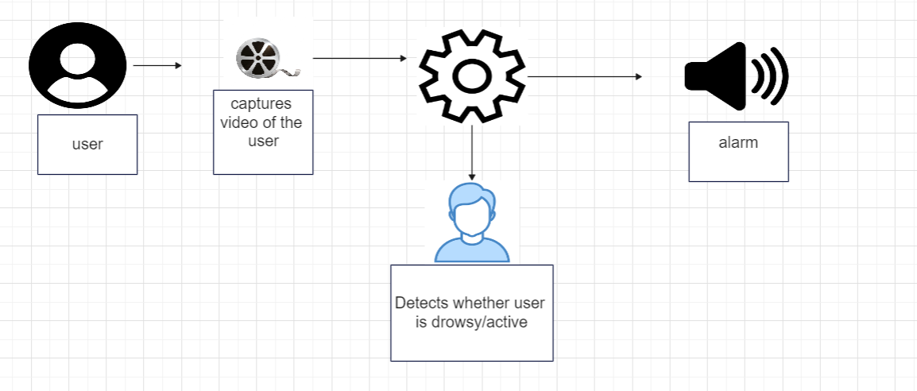

**Journal Publication**